**Token Actions:**

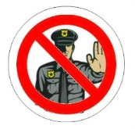**Blackmail –** Eliminate a cop. Gain 1 vp. Take 1st loot pick marker.

**Disguise –** Take another turn.

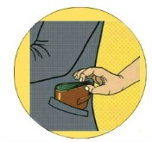**Lift –** Take one item from any mark directly into hand. Ignore card action. If suspicion/cops are drawn, place in group heist area.

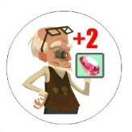**Opportunity –** When selling at the Pawn Shop, gain + 2 vp.

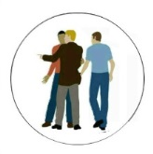**Divide and Conquer –** When the loot is divided, if there is any extra, you can take 1 before the rest goes to the Pawn Shop Exchange.

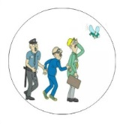**Distraction –** Eliminate a cop. Draw from same mark shown on the cop card. Item drawn is put directly into hand. If suspicion/cops are drawn, place in group heist area.

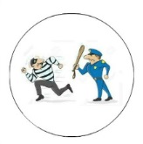**Rat Out –** Force one player to return one item into group heist for round.

**Suspicion –** Add one suspicion for the round.

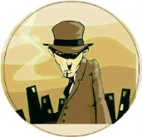**Leader –** When dividing the loot, you can take first pick, next pick is clockwise from you.

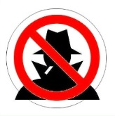**Just say No! –** Play this to counter any player who is using an action token. Discard both.

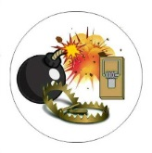**Trap –** Add one trap to your hand.

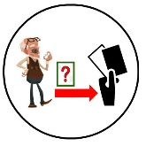**Pawn Shop Steal –** Steal any one item from the Pawn Shop exchange.

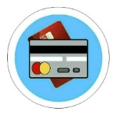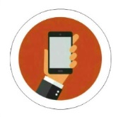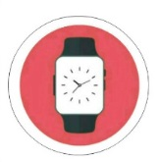

**Items –** Can be used for completing contracts, trading at the Pawn Shop Exchange, etc.